**EX3   
Itay Grinberg 209413277  
Guy Ganot 207044363**

**Types:**

Vehicle – Super class with generic properties that specific types of vehicles inherit from.  
Contains the “basic” properties and methods that every specific type of vehicle have in common.

VehicleInfo – A class that contains info about the vehicle owner, such as name and phone number, and also holds a Vehicle property which is a Vehicle object.

Car, Truck, Motorbike – Subclasses that inherit from Vehicle superclass. They all posses the same properties and methods that ‘Vehicle’ has, but each one has a few different methods and properties of their own.

Wheel – A class to represent a single wheel, it holds the properties of a Manufacturer and current and max values for air pressure.

EnergyType – An abstract superclass that holds values of current and maximum amount of energy  
Fuel, Electric – Two subclasses that inherit from EnergyType inorder to get it’s properties of maximum and minimum energy, and hold methods for adding energy (fuel or battery).

eFuelType – An enum of all the kinds of fuels and energies (Soler, Octan95, …)

eDoorColors – An enum of all the kinds of available colors for door colors. (White, Red,...)

eLicenseType – An enum for all the kinds of license types available to a motorbike. (A1, AA, …)

eVehicleStatus – An enum for all the statuses of a vehicle.(InRepair, Repaired, PayedFor)

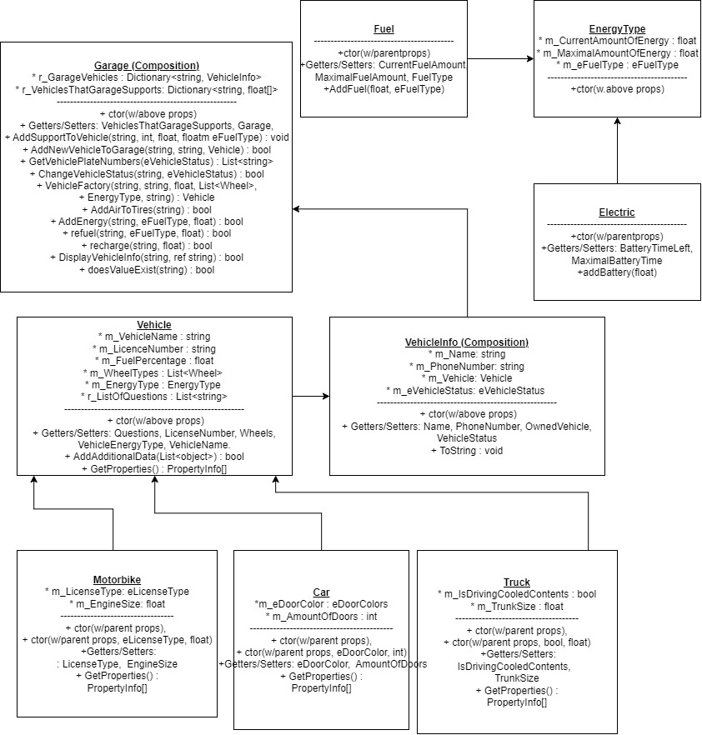ConsoleUI – A UI class that runs the UI part and interacts with the users by asking questions and gathering inputs.  
It exists so it could sent the data out to GarageLogic, where logical operations are being made.